TEAM 5PY SCREENSHOTS

QUESTION 5

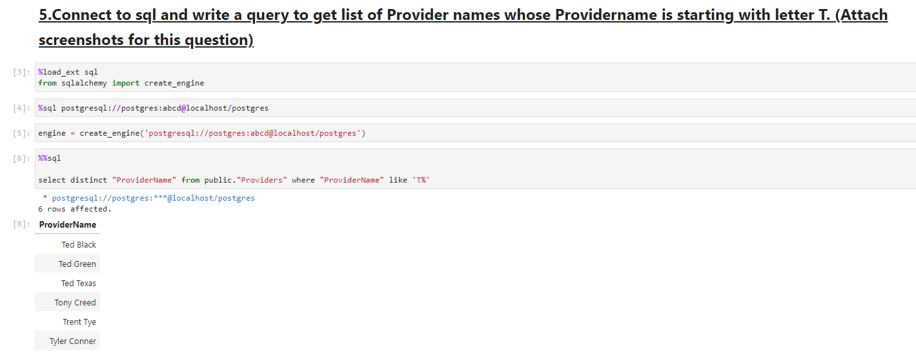

QUESTION 60

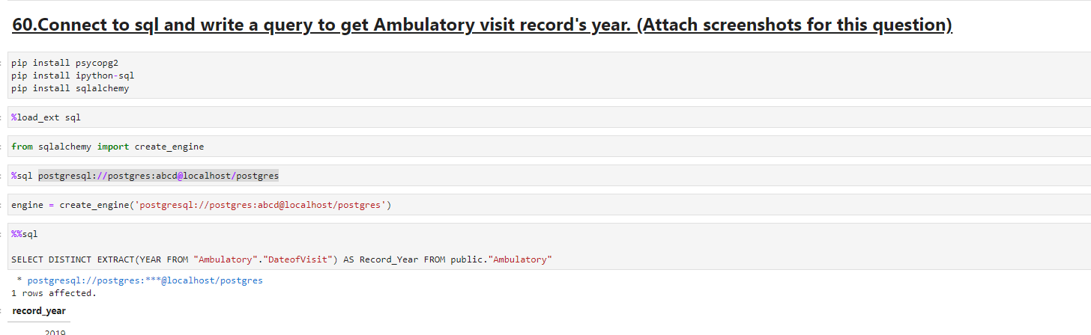

ADDITIONAL QUERIES

\*\* We used several charts in our additional queries, some of which only display on web browsers. So we’ve added screenshots of that to our file, in case the full viewing experience is missing in our file.

QUESTION 81B:

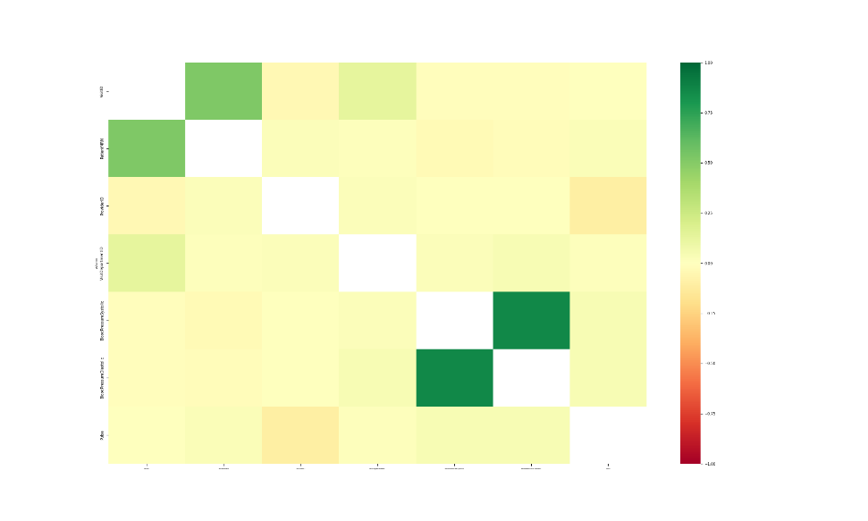

QUESTION 82 (TIME LAPSE GIF)



QUESTION 99 (HTML DASH APP)

